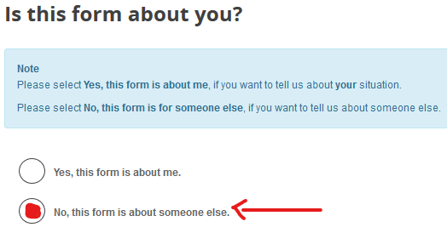 | On the first page select "No, this form is about someone else"
Click Next -> to take you to the next page
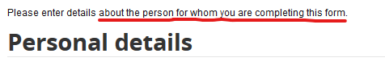 | This page is asking you for the details of the person who is at risk. This helps us link the details to our CareFirst system.  NB. If you don't have a mobile phone then just enter a contact number, for the person.
Click Next -> to take you to the next page
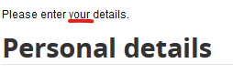 | On this page enter your details.
Click Next -> to take you to the next page
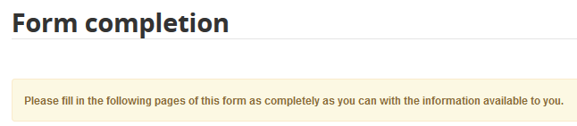 | This page is the start of the form proper. Please fill in the following pages of this form as completely as you can with the information available to you.  Some questions are required and marked with an asterisk *.  It will ask you for some of the same details as above, this is expected – please complete.  A navigation of the form sections is found on the right.
When the form is complete click Submit to send the form us. You will receive a confirmation email that the form has been submitted.

